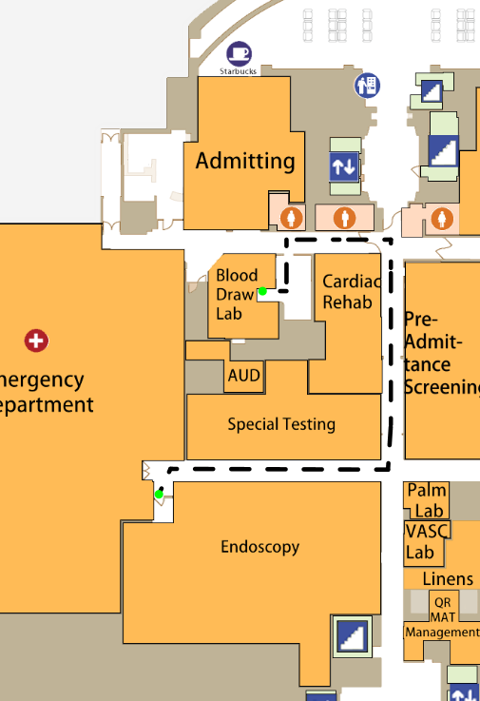

DocTour User Manual

Team Khaki Kappas

Worcester Polytechnic Institute

CS3733-D20-D02 - Prof. Wong

5/12/2020

**Team Khaki Kappas**

Nathan Bargman - Lead Software Engineer - NathanBargman

John-Ryan (J.R.) Dunn - Assistant Lead Software Engineer - SocraticPhoenix

Tyler Bouwens - Assistant Lead Software Engineer - trbouwens

Tim McCarthy - Project Manager - temccarthy

Matt Vindigni - Scrum Master - mvindigni

Abhijay (AJ) Thammana - Product Owner - athammana

Christian (Max) Schrader - Documentation Analyst - cm-schrader

Ryan Astor - Software Engineer - RyanAstor

Greg Marshall - Software Engineer - Gregory-Marshall-2023

Jieyuan (Jeff) Song - Software Engineer - jysong-jeff

Chris Myers - Coach - C7C8

Table of Contents

2 Table of Figures 4

3 Introduction 6

4 Users 7

4.1 Types of Users 7

4.1.1 Guest 7

4.1.2 Visitors and Patients 7

4.1.3 Staff Members 7

4.1.4 Administrators 7

4.2 Logging In 7

4.3 Password Changing 9

5 QR 10

5.1 QR Codes 10

5.1.1 Introduction 10

5.1.2 Paths 10

5.1.3 Signing In 10

5.1.4 Creating a new User 10

5.1.5 Timeouts 10

5.2 QR Scanning 11

5.3 QR Creation 14

6 System Bar 17

6.1 Back Button 18

6.2 Login and Control Panel 19

6.3 QR Scanner 20

6.4 Make Requests Page 21

6.5 Wi-Fi Information Page 22

6.6 General Information Pages 23

6.7 Admin Panel 25

6.8 Voice Control 25

6.9 Emergency Button 26

6.10 Weather 28

6.11 Date And Time 29

7 Map Screen 30

7.1 Pathfinding Sidebar 31

7.1.1 Hamburger Button 32

7.1.2 Pathfinding Area 33

7.1.3 Quick Access Buttons 36

7.1.4 Text Directions 37

7.1.5 Switching Hospitals Button 39

7.1.6 Floor Buttons 40

7.2 Map Viewer 41

7.2.1 Help Button 43

7.2.2 Map Legend 44

7.2.3 Hide Map Legend Button 45

7.2.4 Top Bar Directions 46

7.2.5 Street View 47

8 Requests System 48

8.1 Emotional Support 49

8.2 Consultant 50

8.3 Tech Support 50

8.4 Medicine 50

8.5 Custodial 51

8.6 Translator 51

8.7 Audio Visual 51

8.8 Repair 52

8.9 Transportation 52

8.10 Mortuary (OLD) 52

8.11 Mortuary (API) 53

8.12 Viewing Non-API Requests 55

9 Administration Tools 56

9.1 Settings menu 56

9.2 Admin Panel 57

9.2.1 Import/Export DB 57

9.3 Map Editor 58

9.3.1 Editor Sidebar 59

9.4 User Management 62

10 Acknowledgments 64

# Table of Figures

Figure 1 The login button on the system bar 8

Figure 2 The Login Popup 8

Figure 3 The Change Password Popup 9

[Figure 4 Opening the QR Code scanner. 11](https://wpi0-my.sharepoint.com/personal/cmschrader_wpi_edu/Documents/Team%20K%20DocTour%20User%20Manual.docx#_Toc40218139)

[Figure 5 Scanning a QR Code. 12](https://wpi0-my.sharepoint.com/personal/cmschrader_wpi_edu/Documents/Team%20K%20DocTour%20User%20Manual.docx#_Toc40218140)

[Figure 6 Logging in with a QR Code. 13](https://wpi0-my.sharepoint.com/personal/cmschrader_wpi_edu/Documents/Team%20K%20DocTour%20User%20Manual.docx#_Toc40218141)

[Figure 7 Create a QR Code. 14](https://wpi0-my.sharepoint.com/personal/cmschrader_wpi_edu/Documents/Team%20K%20DocTour%20User%20Manual.docx#_Toc40218142)

[Figure 8 QR Code pathfinding settings. 15](https://wpi0-my.sharepoint.com/personal/cmschrader_wpi_edu/Documents/Team%20K%20DocTour%20User%20Manual.docx#_Toc40218143)

[Figure 9 QR Code new user settings. 15](https://wpi0-my.sharepoint.com/personal/cmschrader_wpi_edu/Documents/Team%20K%20DocTour%20User%20Manual.docx#_Toc40218144)

[Figure 10 QR Code existing user settings. 16](https://wpi0-my.sharepoint.com/personal/cmschrader_wpi_edu/Documents/Team%20K%20DocTour%20User%20Manual.docx#_Toc40218145)

Figure 11 System Bar on App Start Up 17

Figure 12 Back Button 18

Figure 13 Control Panel 19

Figure 14 QR Button 20

Figure 15 Make a Request Button 21

Figure 16 Wi-Fi Information Button 22

Figure 17 Wi-Fi Information Page 22

Figure 18 General Information Button 23

Figure 19 About Page 24

Figure 20 Credits Page 24

Figure 21 Voice Control Button 25

Figure 22 Emergency Button 26

Figure 23 Emergency Screen 27

Figure 24 Emergency Screen Response 27

Figure 25 Weather Display 28

Figure 26 Date and Time Display 29

Figure 27 Map Screen 30

Figure 28 Pathfinding Sidebar 31

Figure 29 Hamburger Button 32

Figure 30 Pathfinding Sidebar Hidden 33

Figure 31 Pathfinding Area 33

Figure 32 Location Text Fields 34

Figure 33 Location Field Dropdown List 34

Figure 34 Fuzzy Search 34

Figure 35 Clear Text Field Button 35

Figure 36 Location Switch Button 35

Figure 37 Accessible Path Switch 35

Figure 38 Quick Access Buttons 36

Figure 39 Text Directions 37

Figure 40 Extended Text Directions 37

Figure 41 Save Directions Button 38

Figure 42 Save Directions Popup 38

Figure 43 Hospital switching button 39

Figure 44 Floor Buttons 40

Figure 45 Faulkner Floor Buttons 40

Figure 46 Main Campus Buttons 40

Figure 47 Floor Button Colors 41

Figure 48 Map Viewer 41

Figure 49 Pathfinding Example 42

Figure 50 Elevator and Stair Icons 42

Figure 51 Help Button 43

Figure 52 Map Screen Help Overlay 43

Figure 53 Map Legend 44

Figure 54 Hide Map Legend Button 45

Figure 55 Hide Map Legend Button Pressed 46

Figure 56 Top Bar Directions 46

Figure 57 Street View 47

Figure 58 API Requests Screen [Non-Logged In (top), Staff Logged In (bottom)] 48

Figure 59 Request Screen for Staff 49

Figure 60 Mortuary API 53

Figure 61 View Tickets Screen 55

Figure 62 Settings Screen 56

Figure 63 Accessing the Admin Panel 57

Figure 64 Editing Screen 58

Figure 65 Editor Sidebar 59

Figure 66 Edit a Node 60

Figure 67 Edit an Edge 61

Figure 68 The Users Menu 62

Figure 69 The Edit User Window 63

Figure 70 The User Creation Screen 63

# Introduction

DocTour is a hospital kiosk application which can assist with hospital navigation, service request tracking, and administration. It allows hospital guests to quickly get directions through the hospital and request services. Hospital staff and administration can access these same functions in addition to more types of services and the ability to manage the hospital and its guests to provide. This User Guide is split into several sections covering specific features of the application.

**Users:** Section 4 covers the types of users of DocTour along with what features they have permission to access. It explains how to log in and manage credentials.

**QR:** Section 5 covers the use of DocTour’s QR code features. QR codes can be distributed to guests to allow them to instantly log in to kiosks and view premade directions.

**System Bar:** Section 0 covers the use of the System Bar that is always present at the bottom of the screen. It is the primary method of navigating to the different features of the application.

**Map Screen:** Section 7 covers the use of the Map Screen for navigation. This is the default screen of the application and provides users with directions to different locations in the hospitals.

**Request System:** Section 8 covers the use of the Request System for tracking services in the hospital. The Request System allows users to submit service requests which can then be assigned to and completed by qualified staff members.

**Administration Tools:** Section 9 covers the use of the DocTour’s administrative features. This includes high level management of users, editing the map, and application settings.

DocTour was created as part of the course CS 3733, Software Engineering, at Worcester Polytechnic Institute taught by Professor Wilson Wong and in collaboration with Brigham and Women’s Hospital.

# Users

## Types of Users

There are different kinds of users in the pathfinding application. Each type of user has different permissions regarding what features, requests, and settings they can access. There are 4 types of users: guest, patients and visitors, staff members, and administrators.

### Guest

The guest user is the default user of the application. They have access to pathfinding, the QR code scanner, and a limited number of service requests, as discussed in section 8.

### Visitors and Patients

Patients and visitors have the same permissions as the guest user.

### Staff Members

Staff members have all the functionality of visitors and patients, and have access to control panel (see section 6.1) after logging in. The control panel gives staff members access to the View Requests screen, the QR generator, and the password editor.

### Administrators

Administrators have full access to the application. After logging in as an administrator, the admin button appears on the system bar as shown in Section 6.7. This button opens the admin panel, which gives the administrator access to higher system level functionality. See Section 9 for more details on what tools can be used.

## Logging In

To login, click on the account button on the bottom left corner of the system bar (Figure 1). This will open the login popup. Enter your username and password there (Figure 2). If your username or password is incorrect, a notification will tell you to try to enter it again. On successful login, you will be sent back to the home screen. To log out, simply click on the account button and click the logout button in the corresponding window.

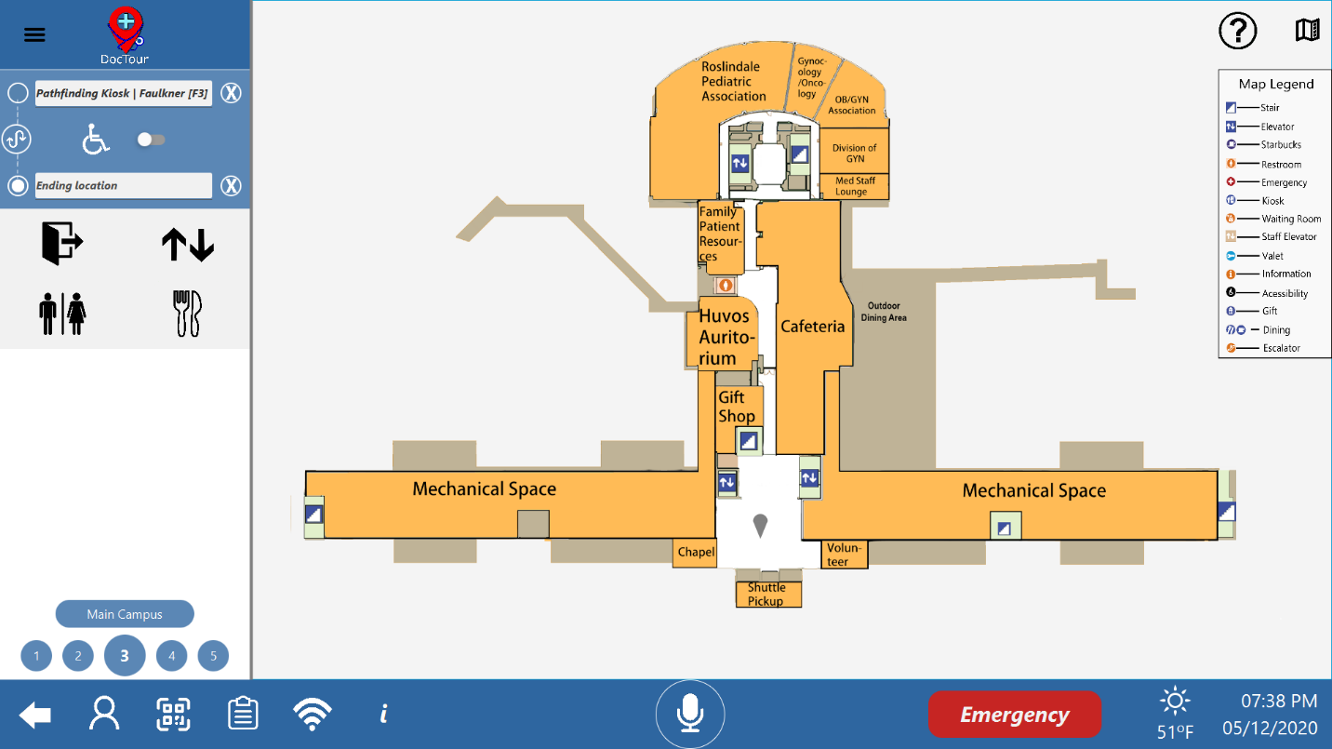

Figure 1 The login button on the system bar

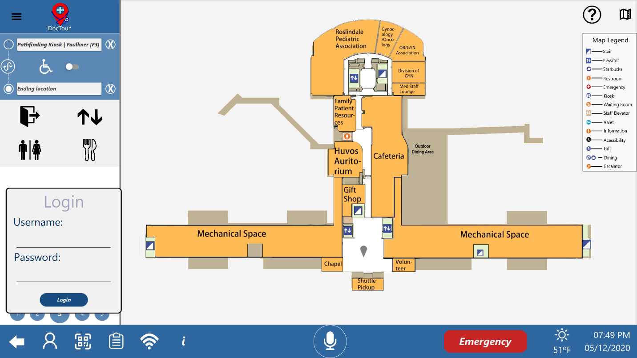

Figure 2 The Login Popup

## Password Changing

To change your password, login and click the password button in the account panel. When the change password/pin popup appears (Figure 3), you can change either your login password on the left or change your QR pin on the right. The new password and confirmation new password must both match to change it successfully.

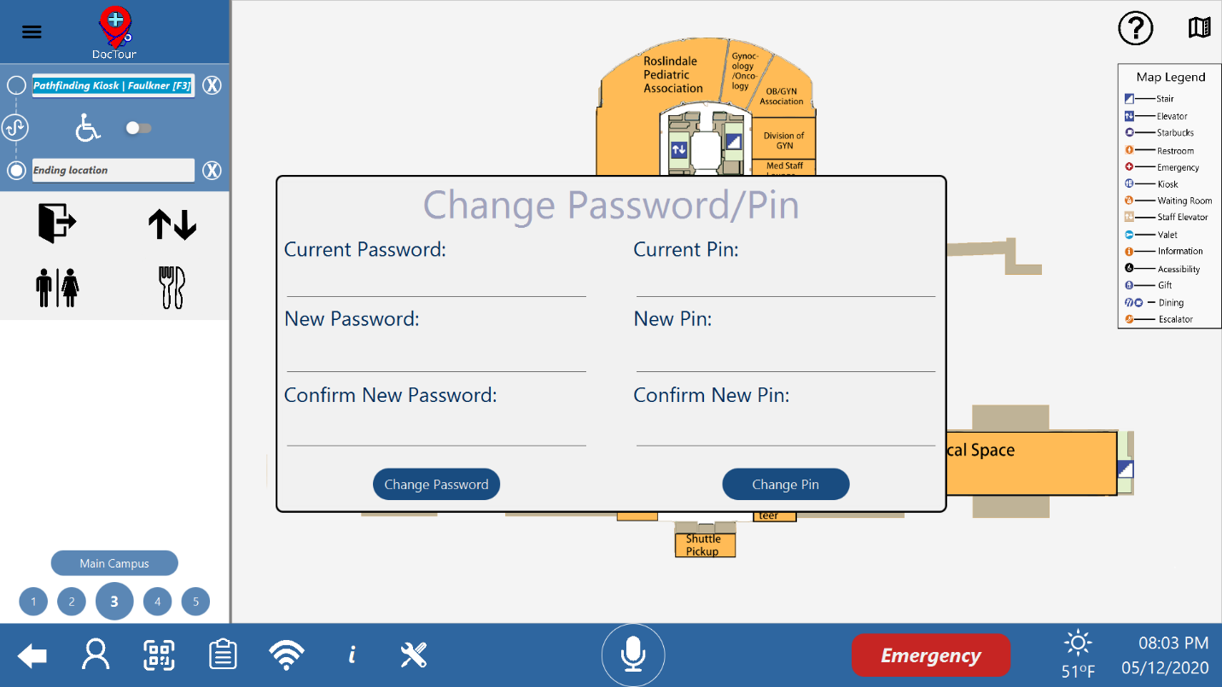

Figure 3 The Change Password Popup

# QR

## QR Codes

### Introduction

QR Codes have three distinct capabilities. They can be used to save paths, to sign in a user, or to create a new visitor or patient user.

### Paths

A QR Code may have a starting location, an ending location, and a floor associated with it. All are optional. If none are specified, the QR Code will not change the current path. If only one of starting or ending location is specified, the QR Code will use the currently selected location (either ending or starting, respectively) as a default. If a floor is specified, the QR Code will display that floor upon being scanned.

This allows QR Codes to be used to send direction to visitors and staff, as well as pull up the same directions easily on multiple kiosks.

### Signing In

A QR Code may be associated with an existing user. The QR Code will automatically sign that user in if they are a visitor or patient. Staff level users will have to log in with a pin.

This allows QR Codes to be put on id cards or bracelets to allow painless signing in on multiple kiosks.

### Creating a new User

A QR Code may be associated with a new user’s name and username. The QR Code will then create the user if they could not be found in the system, or automatically log them in if they were found. The QR Code may only create visitor or patient users.

This allows temporary visitors or new patients to be automatically registered in the kiosk, without the need for an admin to explicitly add a new user.

### Timeouts

A QR Code may have a timeout between 1 hour and 12 months. The QR Code will no longer work after the timeout expires.

This allows QR Codes to only work for a certain period of time, such as the duration of a visit or the duration of a patient’s stay.

## QR Scanning

To scan a QR Code, first press the QR Code Scanner button on the system bar to open the QR Scanner (Figure 4).

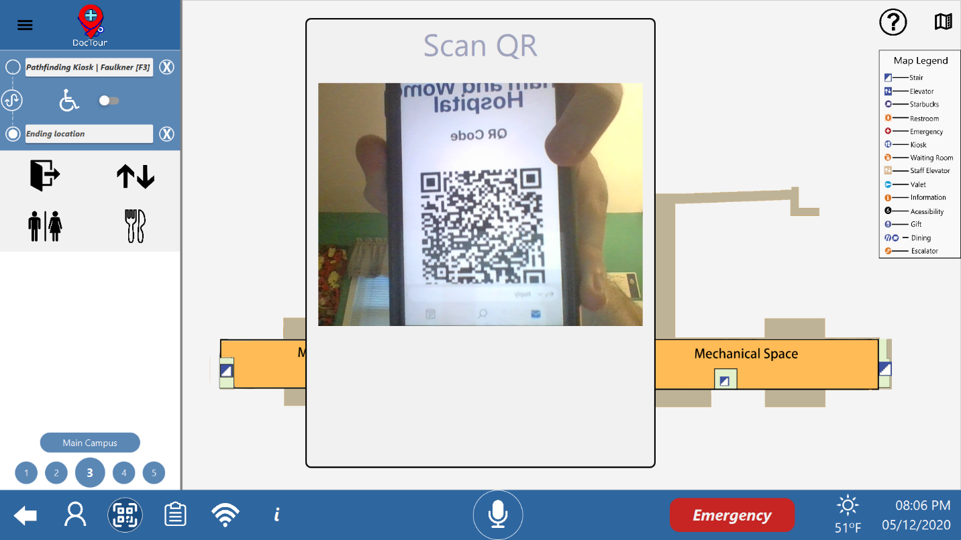

Figure 4 Opening the QR Code scanner.

Next, hold the QR Code (either on your phone, bracelet, or ID card) up to the kiosk’s camera so that it is clearly showing in the QR Scanner’s video feed (Figure 5).



Figure 5 Scanning a QR Code.

If the QR Code is not associated with a user, or if the user is a visitor or patient, the QR Scanner will close and perform the necessary actions (logging a user in or displaying a path). If the QR Code is associated with a staff user, they will have to log in with their pin number (Figure 6).

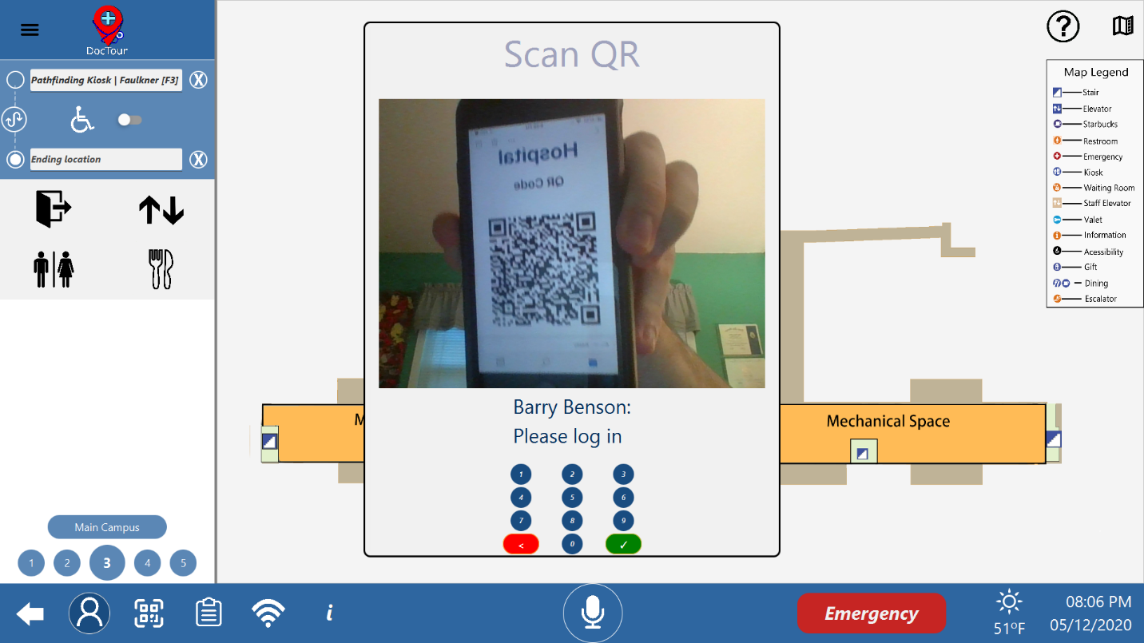

Figure 6 Logging in with a QR Code.

## QR Creation

To create a QR Code, you must first log in as a staff member. Then, open the control panel and press the Create QR button (Figure 7).

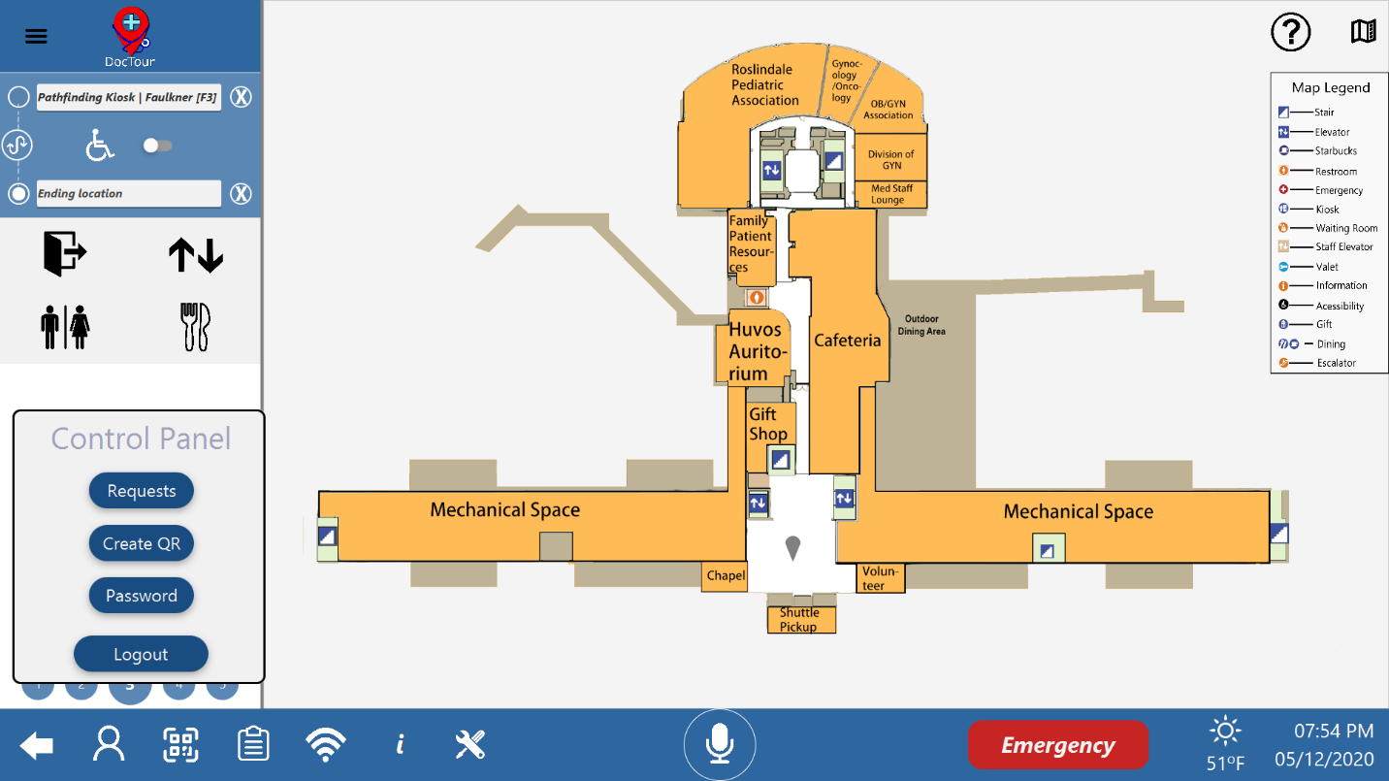

Figure 7 Create a QR Code.

To set the directions associated with the QR Code, use the pathfinding settings (Figure 8).

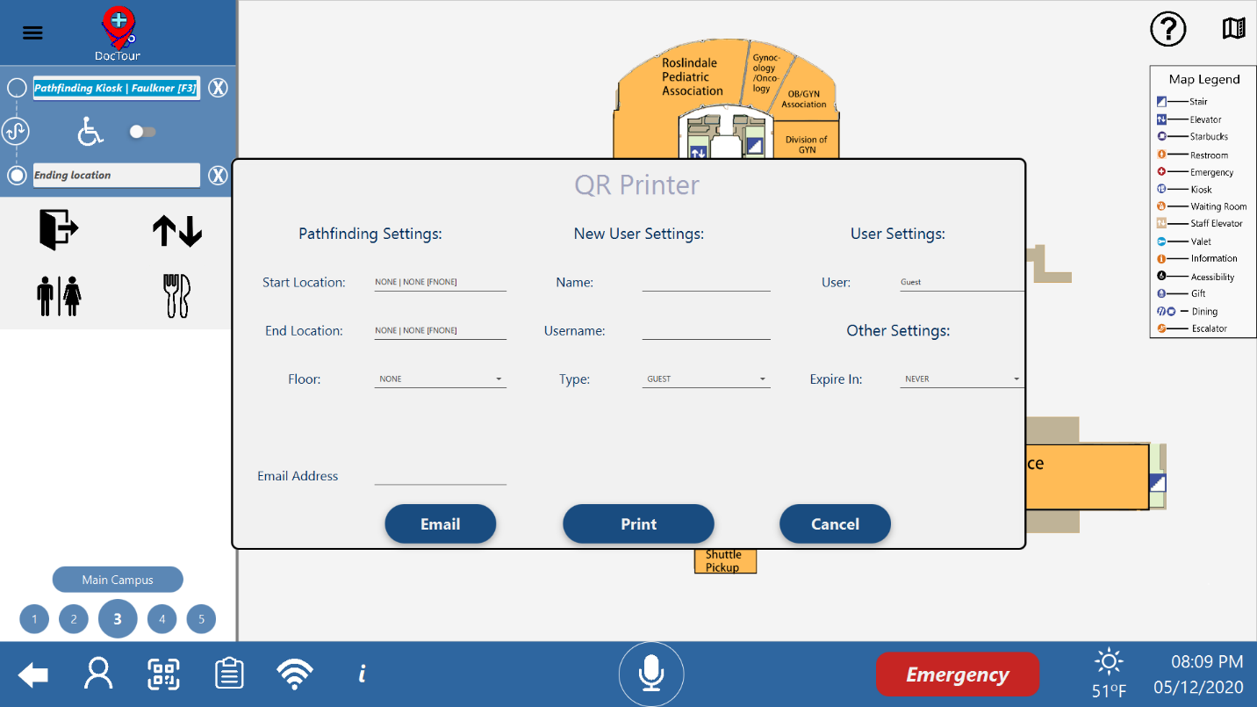To have the QR Code create a new user, use the new user settings.

Figure 8 QR Code pathfinding settings.



Figure 9 QR Code new user settings.

To have the QR Code log in an existing user, use the user settings (Figure 10). After entering the settings for your new QR Code, you may then either print it or email it.



Figure 10 QR Code existing user settings.

# System Bar



Figure 11 System Bar on App Start Up

The system bar, as highlighted in Figure 11, is constant throughout the entire application for ease of access and use. It has buttons that give access to the rest of the application. It function is as follows.

## Back Button

The back button will get the user back to the last screen they were on or all the way to the main pathfinding screen if they have transitioned to another screen. It is shown in Figure 12.



Figure 12 Back Button

## Login and Control Panel

The login button, as shown in Figure 1, is the way to access all functions of a logged in user. When pressed, the user will be promoted with Figure 2 and the request of username and password. After entering correct credentials, the user is logged in. If they have high enough credentials, pressing the user button again will display Figure 13. For more information about login and users, see section 4.



Figure 13 Control Panel

Pressing Requests will display Figure 58. Pressing Create QR will display Figure 8. Pressing Password will display Figure 3. Finally, if logout is pressed, the kiosk reverts to the standard guest user.

## QR Scanner

If the QR button is pressed, as shown in Figure 14, the QR scanner is opened (Figure 5). For information about how QR codes work, see section 5.



Figure 14 QR Button

## Make Requests Page

If the make a request button is pressed, as shown in Figure 15, the make a request screen is loaded in (Figure 55). For more information about the requests system, see section 8.



Figure 15 Make a Request Button

## Wi-Fi Information Page

If the Wi-Fi information button is pressed, as shown in Figure 15, the Wi-Fi information screen is loaded in (Figure 17).



Figure 16 Wi-Fi Information Button

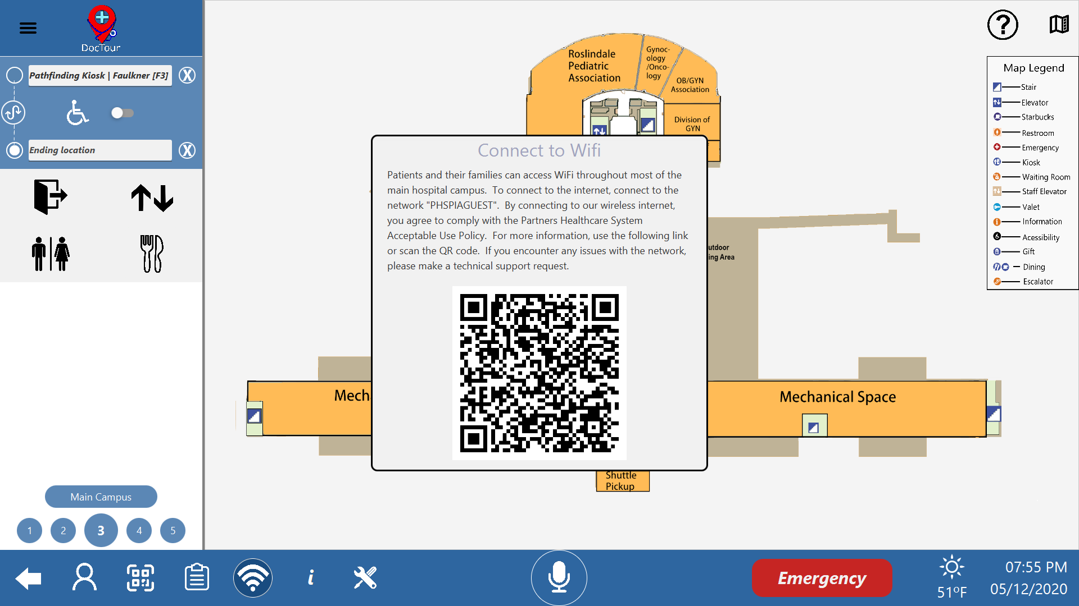

Figure 17 Wi-Fi Information Page

## General Information Pages

If the general information button is pressed, as shown in Figure 18Figure 15, the About Page is loaded in (Figure 19). If the button in the upper right-hand corner of the about page is pressed titled “To Credits Page,” the Credits Page will open, Figure 20. Pressing the button in the same location, now titled “To About Page,” will bring the user back to the About Page.



Figure 18 General Information Button

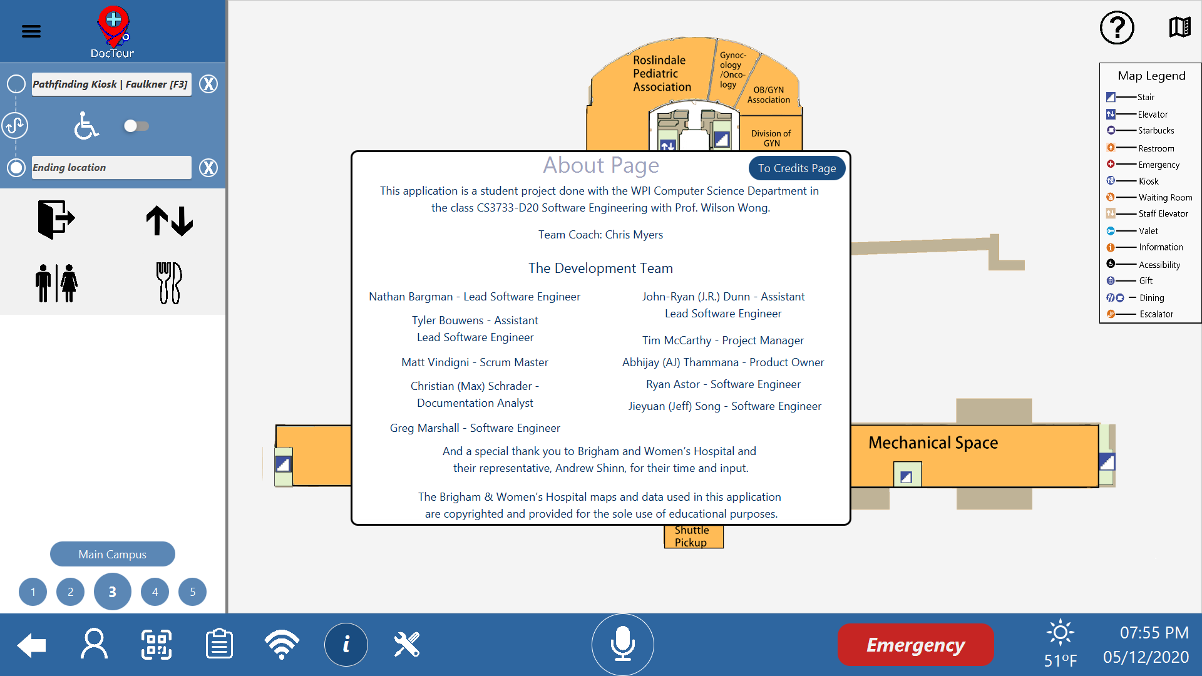

Figure 19 About Page

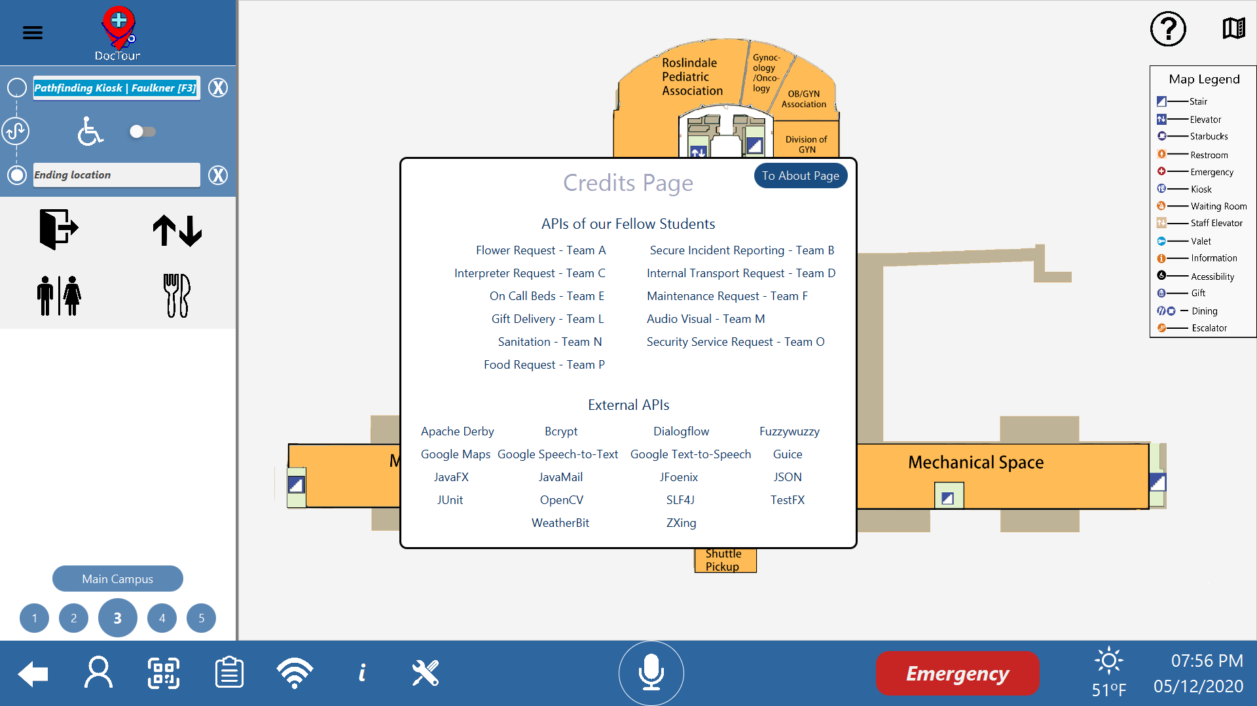

Figure 20 Credits Page

## Admin Panel

If the user is logged in as an Admin, the Admin Panel, Figure 60, is displayed. All further explanations on the panel is in section 9.2.

## Voice Control

By pressing the microphone button in Figure 21, the kiosk will listen for voice input. The can open pages in the applications as well as show a path between any two locations without typing anything in. It will also output voice back to the user to create a more seamless experience.



Figure 21 Voice Control Button

## Emergency Button

If the emergency button is pressed, as shown in Figure 22, the emergency screen is loaded in (Figure 23). This auto generates a top-level request for emergency assistance at the kiosk location. If the user chooses, they can specify the type of emergency. Doing so displays Figure 24 and edits the request to add the new information.



Figure 22 Emergency Button

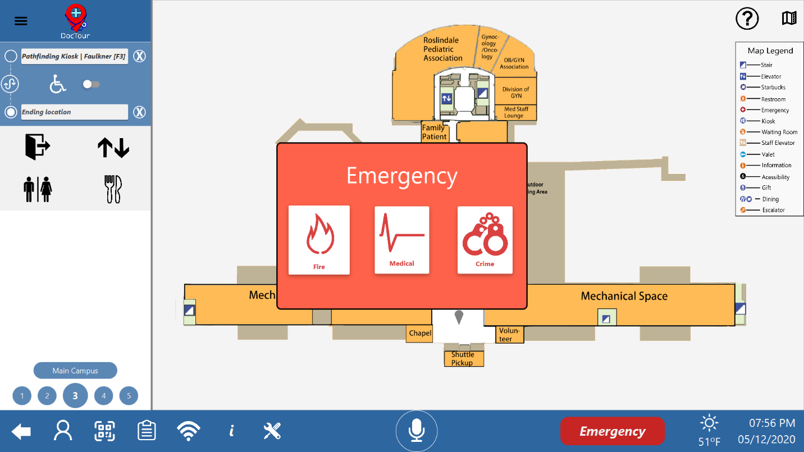

Figure 23 Emergency Screen

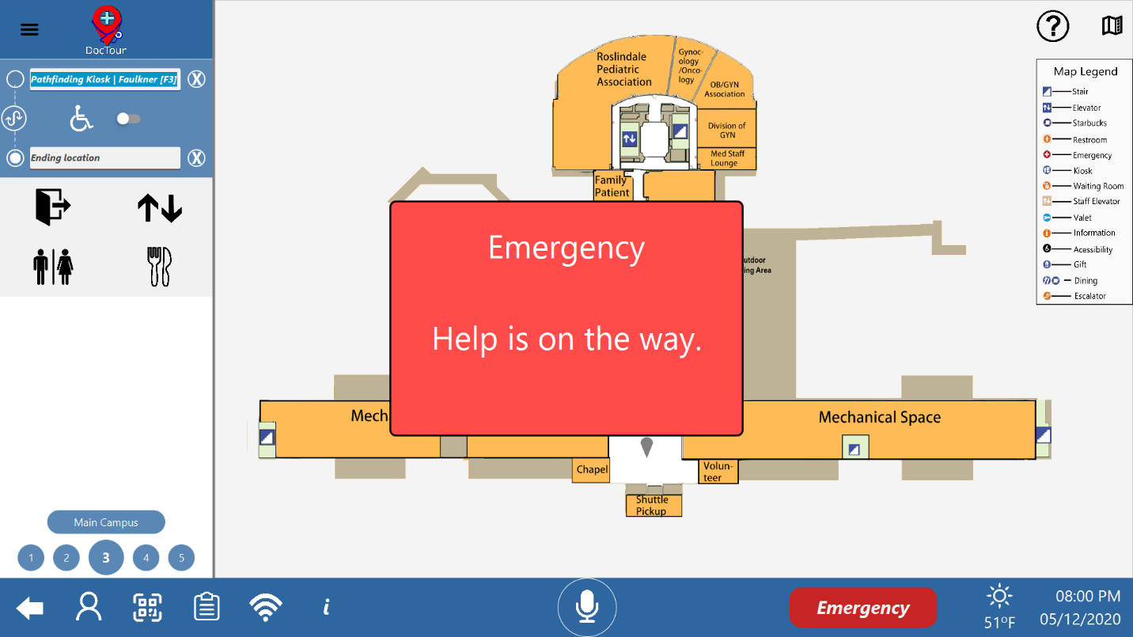

Figure 24 Emergency Screen Response

## Weather

When in the app, the current local weather is displayed on the system bar (Figure 25). This includes current weather conditions and the temperature in Fahrenheit.



Figure 25 Weather Display

## Date And Time

When in the app, the current date and time is displayed on the system bar (Figure 26).



Figure 26 Date and Time Display

# Map Screen



Figure 27 Map Screen

As shown in Figure 27, the map screen consists of the Pathfinding Sidebar and the Map Viewer.

## Pathfinding Sidebar



Figure 28 Pathfinding Sidebar

The Pathfinding Sidebar, as shown in the highlighted area of Figure 28, contains (from top to bottom) the Hamburger Button, the Pathfinding Area, Quick Access Buttons, Text Directions, the Switching Hospitals Button, and the Floor Buttons.

### Hamburger Button

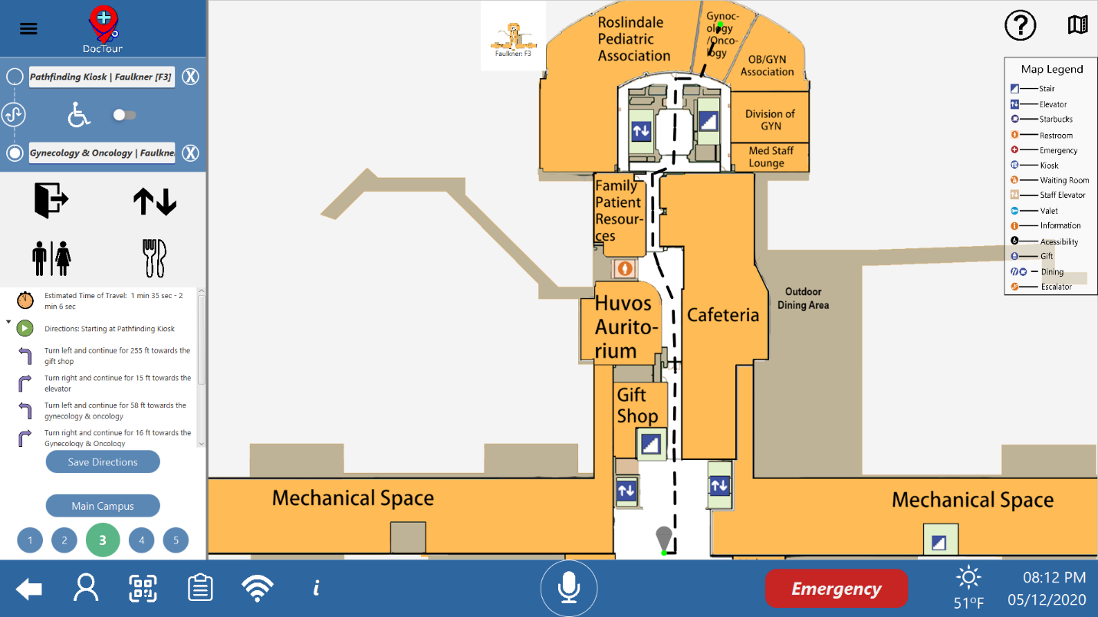

Figure 29 Hamburger Button

The hamburger button, as seen in the highlighted area of Figure 29, will hide the Pathfinding Sidebar and move the Map Viewer to the center of the screen.

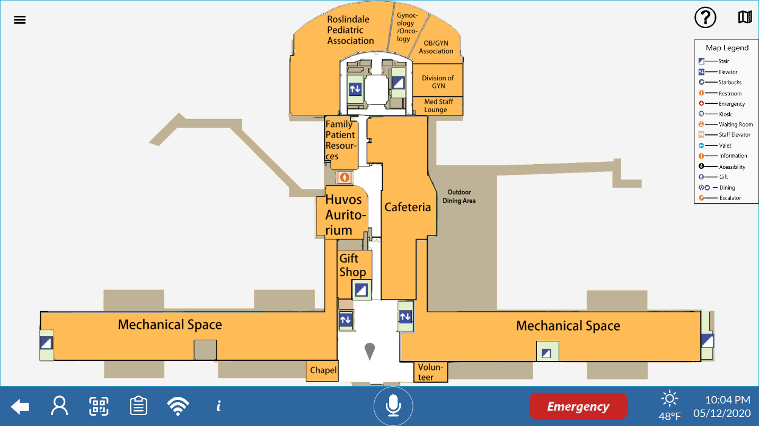

Figure 30 Pathfinding Sidebar Hidden

### Pathfinding Area



Figure 31 Pathfinding Area

The Pathfinding Area, as seen in the highlighted area of Figure 31, contains the Location Text Fields, the Location Switch Button, and the Accessible Path Switch.

#### Location Text Fields

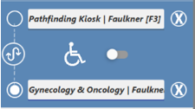

Figure 32 Location Text Fields

There are two Location Text Fields, as seen in the highlighted areas in Figure 32. The upper text field is the starting location. For ease of use, this location is defaulted to the location of the kiosk, which can be changed in the Settings menu. The lower text field is the ending location.

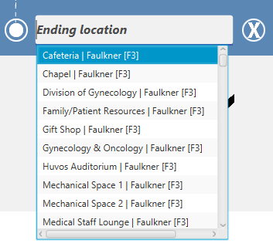

Figure 33 Location Field Dropdown List

The Location Text Fields will drop down a list of locations, as seen in Figure 33, for both hospitals when the text field is selected. The dropdown list will prioritize locations on your current floor and building for ease of use. The list view of locations is scrollable using the scroll wheel or searchable by using a keyboard.

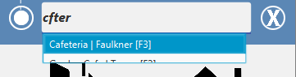

Figure 34 Fuzzy Search

If a user starts typing into the Location Text Fields and makes a minor typo, like the one seen in Figure 34, the application will understand what the user is searching for and still display the desired location at the top of the dropdown.



Figure 35 Clear Text Field Button

The user can quickly clear a text field by clicking the “X” button, as seen next to the Location Text Fields in Figure 35, to clear all the text in the respective text field.

#### Location Switch Button



Figure 36 Location Switch Button

The Location Switch Button, as seen in the highlighted area of Figure 36, will swap the Location Text Fields when pressed. This allows the user to reverse the direction of their path for ease of use.

#### Accessible Path Switch



Figure 37 Accessible Path Switch

The Accessible Path , as seen in the highlighted area of Figure 37, will make the desired path handicap accessible. It does so by removing all forms of travel by stair and using elevators instead.

### Quick Access Buttons



Figure 38 Quick Access Buttons

The quick access buttons, shown in Figure 38, will navigate the user to the nearest locations specified by each button regarding the current kiosk location.

|  |  |  |  |
| --- | --- | --- | --- |
|  | Navigate to the nearest exit. |  | Navigate to the nearest elevator. |
|  | Navigate to the nearest bathroom. |  | Navigate to the neatest dining location. |

### Text Directions

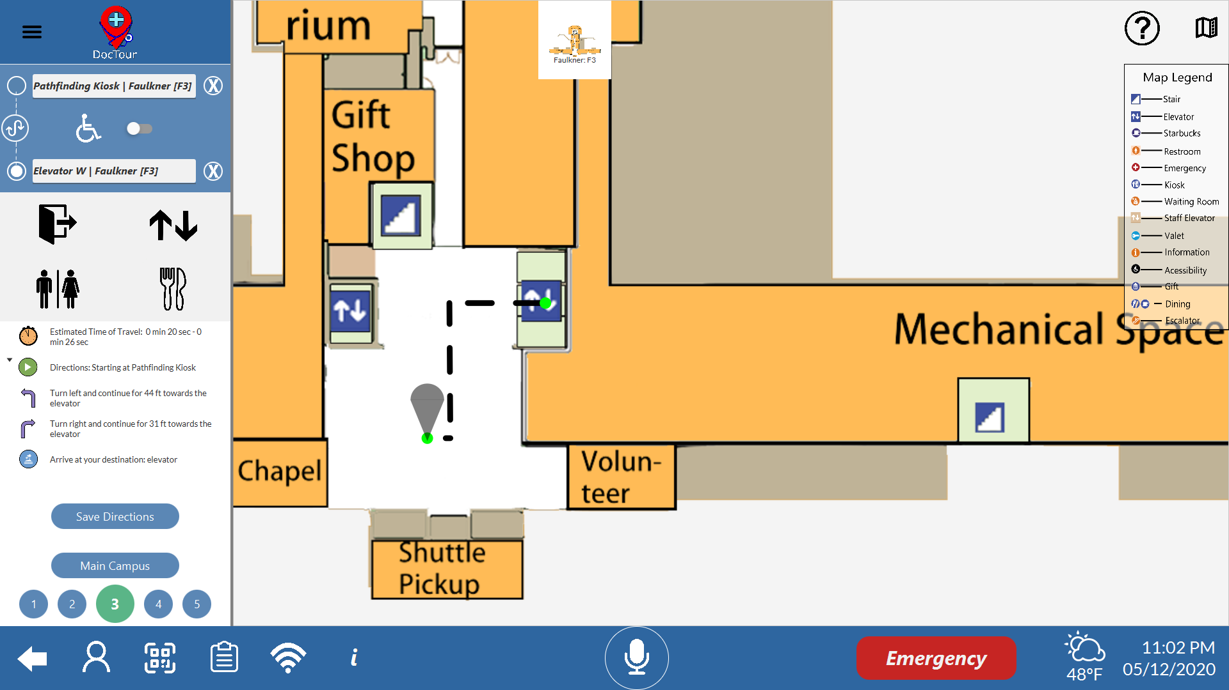

Figure 39 Text Directions

The Text Directions, as seen in the highlighted area of Figure 39, are displayed once a path has been generated. The Text Directions go step by step through the path.

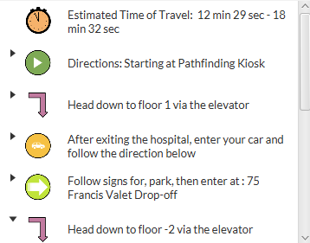

Figure 40 Extended Text Directions

The Text Directions are collapsible by floor, and upon clicking the collapsed directions, it will expand and display the corresponding floor on the Map Viewer. If applicable to the path, the user can click on the directions that take the user across hospitals and it will display the Street View on the Map Viewer.

#### Save Directions

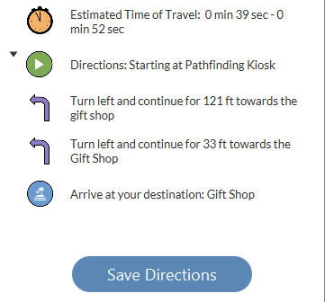

Figure 41 Save Directions Button

When Text Directions are generated, the Save Directions button appears, seen in Figure 41.

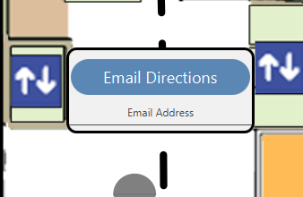

Figure 42 Save Directions Popup

If the user clicks this button, the popup seen in Figure 42 will appear on the Map Viewer. The user can then enter their e-mail address to e-mail the Text Directions to the entered address for later viewing.

### Switching Hospitals Button



Figure 43 Hospital switching button

The hospital switching button, as seen in the highlighted box of Figure 43, is located directly above the Floor Buttons and allows the user to switch the set of maps displayed in the Map Screen. Pressing the button will update the Floor Buttons to represent the currently viewed building / campus.

### Floor Buttons



Figure 44 Floor Buttons

The floor buttons, as seen in the highlighted figure in Figure 41, are located directly below the Switching Hospitals Button and allows the user to switch between floors in their currently viewed building / campus. These are the two sets of floor buttons;

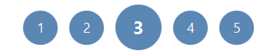

Figure 45 Faulkner Floor Buttons

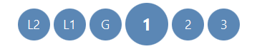

Figure 46 Main Campus Buttons

When getting directions, the floor buttons will change colors.

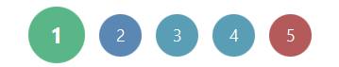

Figure 47 Floor Button Colors

Looking at Figure 44, the color on floor 1 represents the starting floor. If the starting and ending floor are on the same floor, the color of the floor button will be green. The color on floors 3 and 4 represents floors that the path travels through to reach the destination. And last, the color on floor 5 represents the floor the path ends on.

## Map Viewer



Figure 48 Map Viewer

The map viewer, as seen in the highlighted area in Figure 48, the map viewer contains a zoomable map pane that can be zoomed by using the scroll wheel when the Ctrl key is pressed. The map will zoom according to the instantaneous location of curser. Scrolling up will zoom in the map view and scrolling down will zoom out. The map view can be dragged by mouse to focus on other part of the hospital map when zoomed in.



Figure 49 Pathfinding Example

As shown in the highlighted area of Figure 49, after both Location Text Fields are filled in, a path will be generated and shown by an animated dotted line on the Map Viewer.

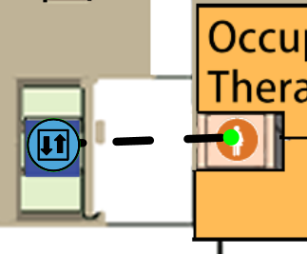

Figure 50 Elevator and Stair Icons

If the path goes through multiple floors, stair and elevator icons will appear where the path would go onto another floor, as seen in the highlighted area of Figure 50. If the user clicks on the icon, it will bring the user to the respective floor that the elevator / stair node is associated with in the path.

### Help Button



Figure 51 Help Button

Clicking on the help button (shown in Figure 51)while viewing the Map Screen will bring up an overlay that contains information on different features the user can use. To close the help overlay, just click anywhere on the screen.

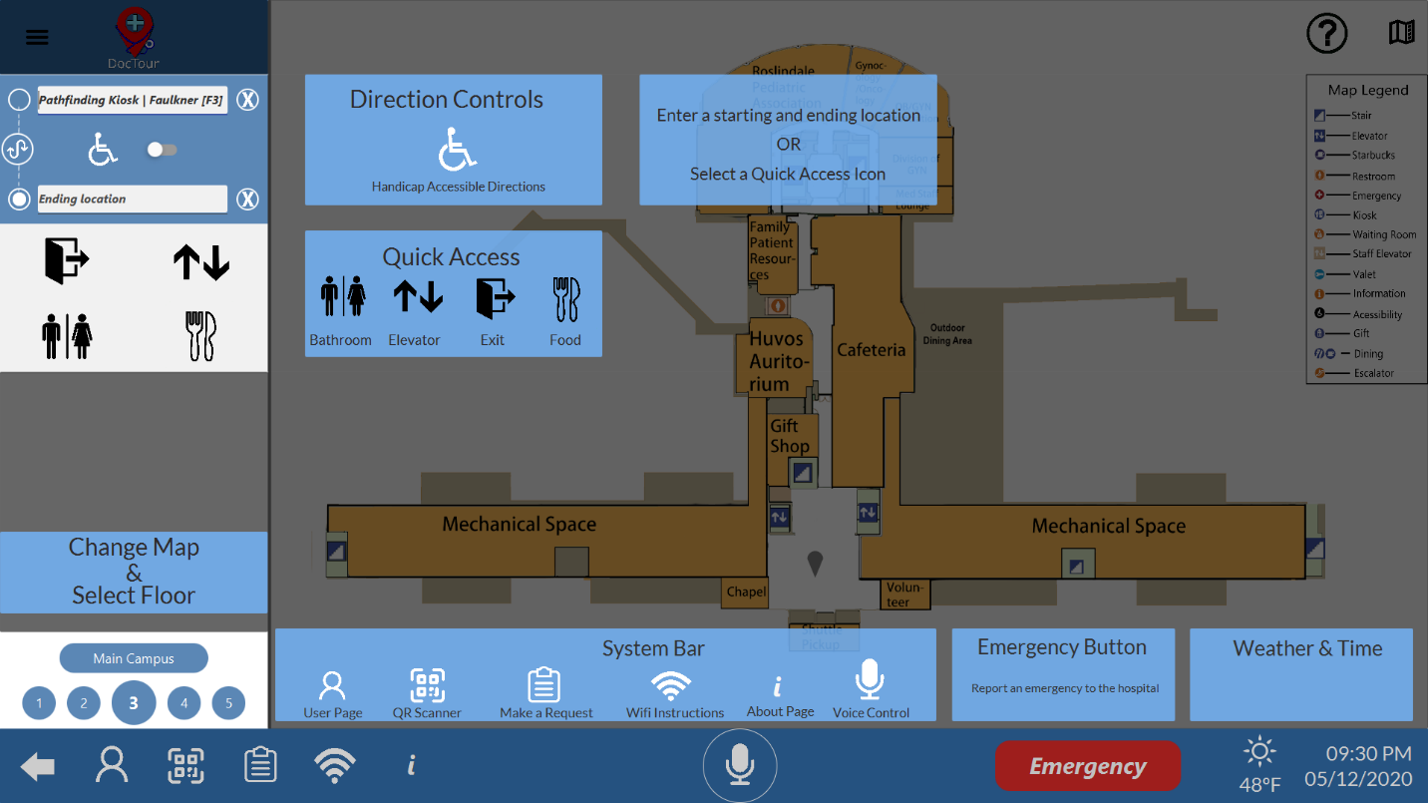

Figure 52 Map Screen Help Overlay

### Map Legend



Figure 53 Map Legend

The Map Legend, as seen in the highlighted area of Figure 53, contains information on the different icons you will see while looking at the maps. It can be hidden by using the

### Hide Map Legend Button



Figure 54 Hide Map Legend Button

The Hide Map Legend Button, as seen in the highlighted area of Figure 54, will hide the Map Legend when pressed. To show the Map Legend again, just click the Hide Map Legend Button again and the Map Legend will appear.

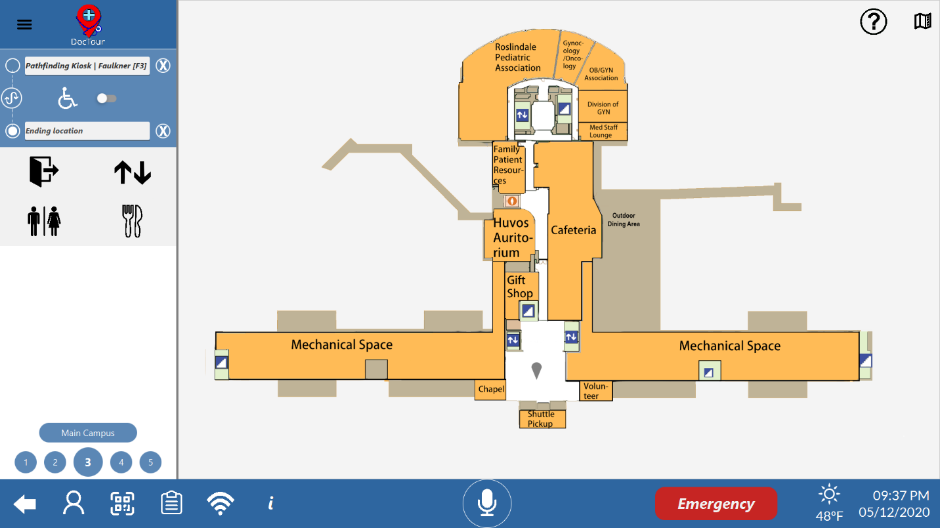

Figure 55 Hide Map Legend Button Pressed

### Top Bar Directions

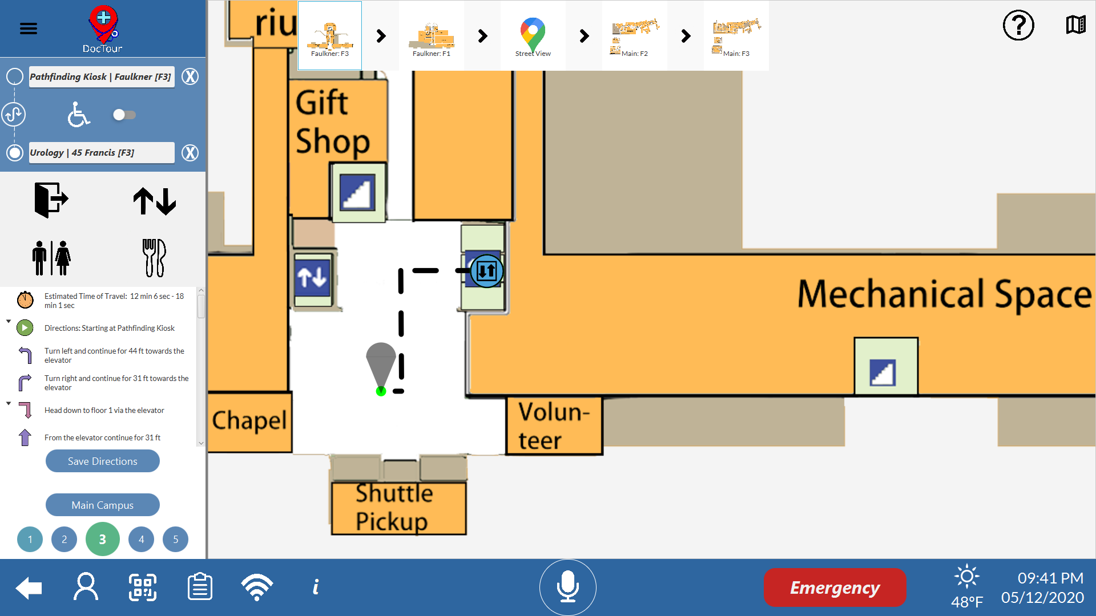

Figure 56 Top Bar Directions

The Top Bar Directions, as seen in the highlighted area in Figure 53, are an overview of the different floors the path generated travels through. Each floor is a clickable button that brings the user to that respective floor and zooms the user in on where the path on that floor is, as seen in the Map Viewer of Figure 53. If a path is generated between two different hospitals, a Street View section will appear in the top bar directions. Clicking on this will bring the user to the Street View.

### Street View

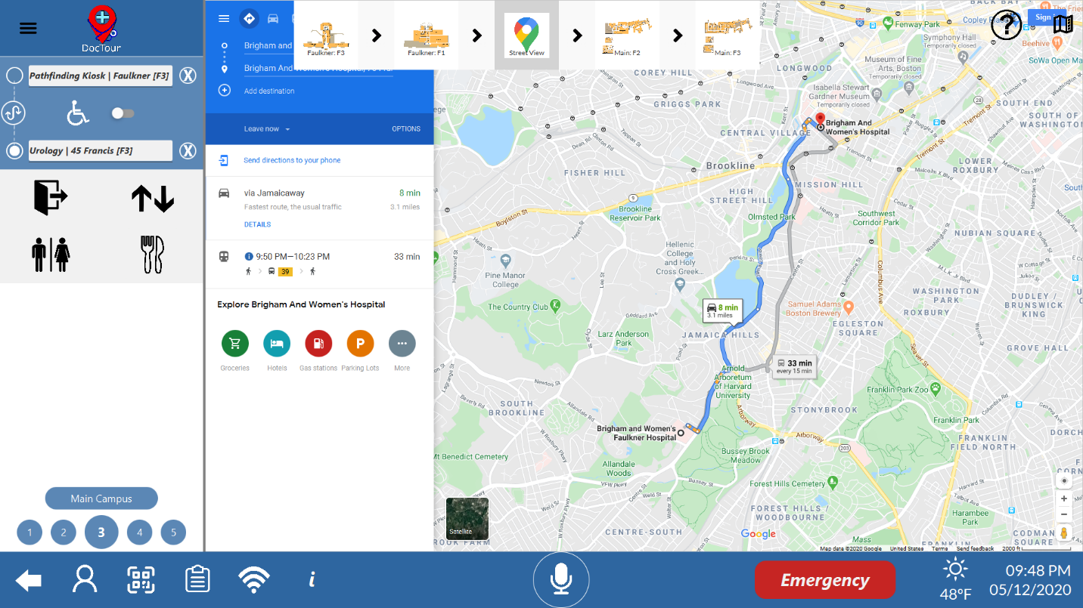

Figure 57 Street View

When a path is generated between hospitals, Street View is displayed in the Top Bar Directions. Street View is a web view of Google Maps and displays directions from the Faulkner Hospital to the Brigham and Women Main Campus. If a path is generated from Brigham and Women Main Campus to the Faulkner Hospital, the Google Map directions will also be reversed.

# Requests System

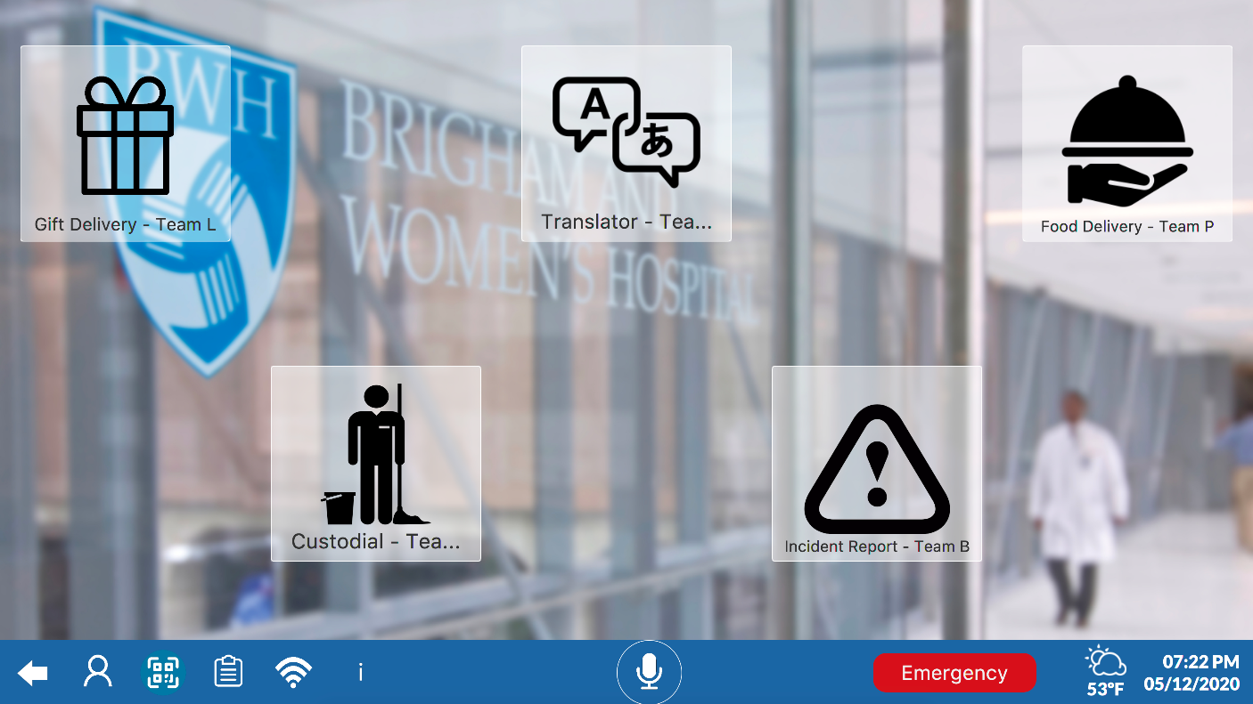

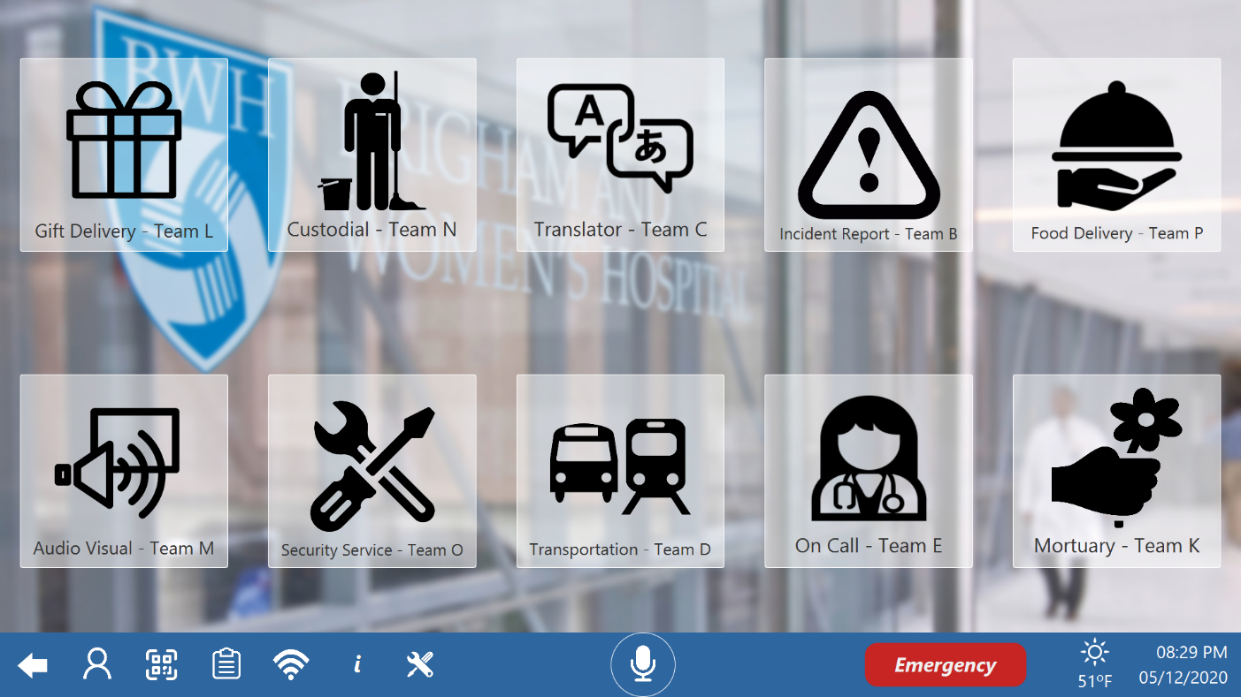

Figure 58 API Requests Screen [Non-Logged In (top), Staff Logged In (bottom)]

This icon marks access to the Request Page

The images in Figure 55 are buttons that open windows to submit their respective request types. The requests in the top picture are open to anyone, the lower contains request for staff only. The Mortuary request manual is below, the others are described by the other teams. This screen is accessible from the clipboard button on the system bar.

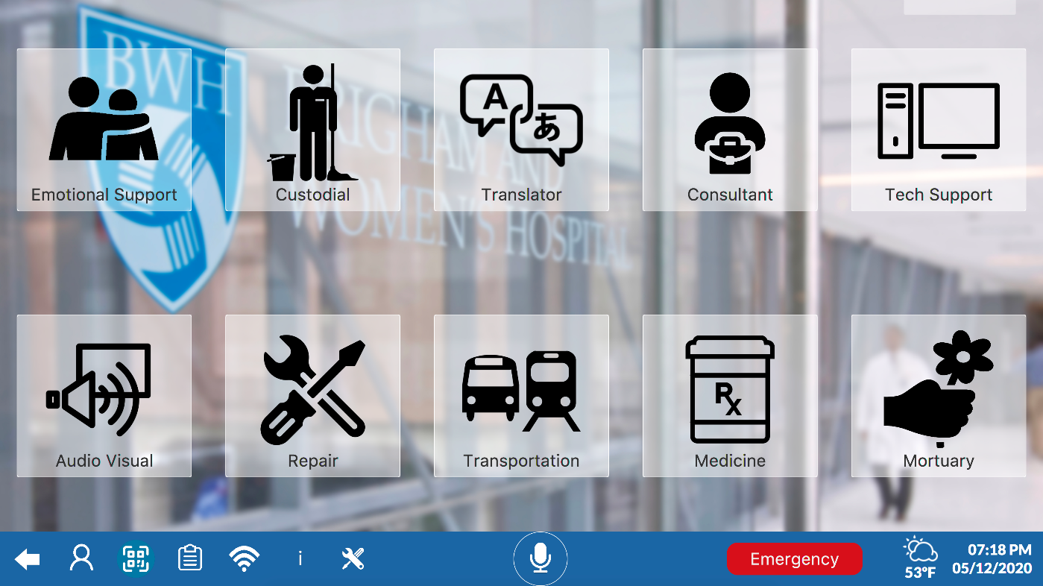

Figure 59 Request Screen for Staff

As in Figure 55, Figure 56 show buttons that open windows to submit their respective request types. These requests however are all housed entirely within the internal database. This window is accessible through the Admin Panel (wrench and driver image)

## Emotional Support

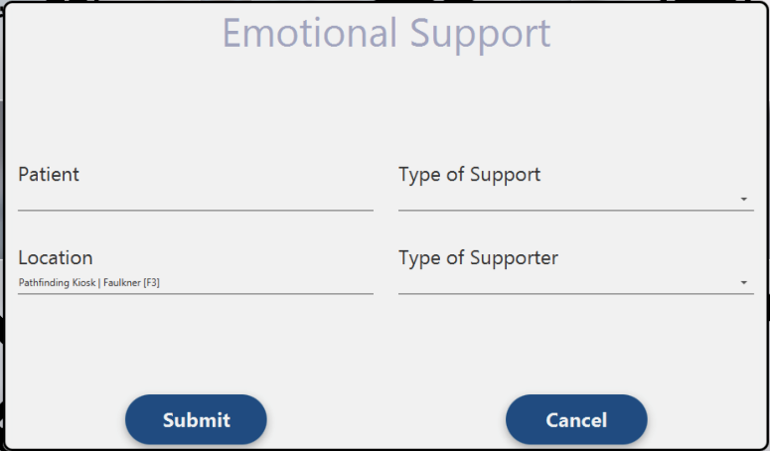Patient: Requester  
Location: Area to send Supporter to  
Type of Support: One of [Grief, Anxiety, Suicidal, Anger, Listener]  
Type of Supporter: One of [Emotional Support Dog, Therapy Dog, Consular, Psychiatrist, Person]

## Consultant

Patient: Requester  
Location: Area to send Consultant  
Type of Support: One of [Insurance, Financial, Payment, Legal]  
Preferred Meeting Date and Time: Day, Time  
Problem Description

## Tech Support

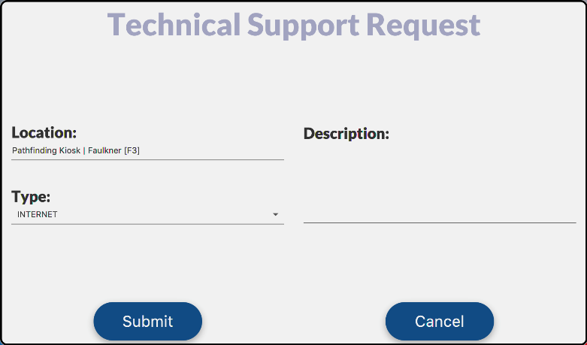Location: Area to send IT  
Type of Support: One of [Internet, Hardware, Software]  
Description

## Medicine

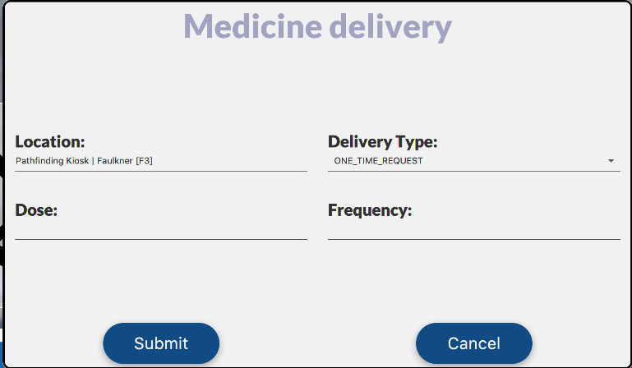Location: Location of Pickup  
Dose  
Delivery Type: One of [Daily, One Time]  
Frequency: Description

## Custodial

Location: Location of hazard  
Type: One of [Spill, Spill-Hazardous, Spill-Bodily-Fluids]

## Translator

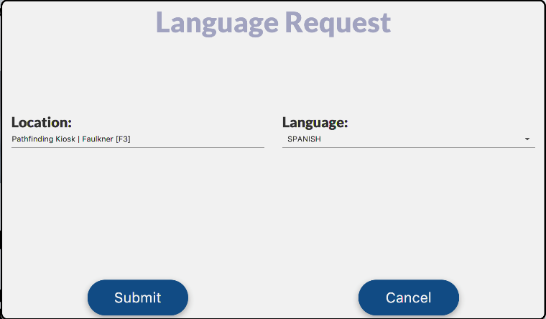Location: Location to send translator  
Language: Accepts any if, if one is not in the drop down ’other’ will open up a text field

## Audio Visual

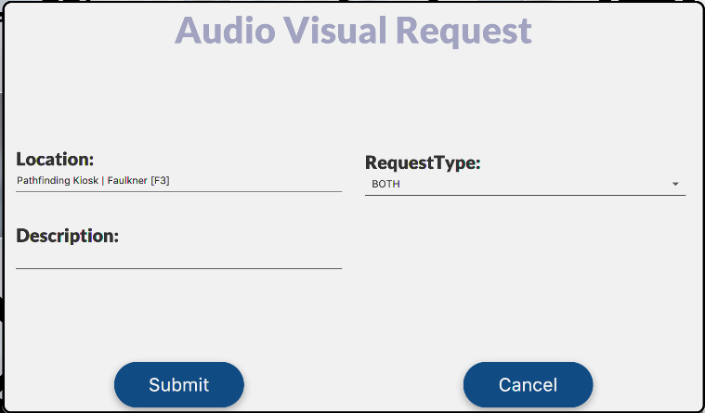Location: Location in need of repair  
Request Type: One of [Audio, Visual, Both]  
Description

## Repair

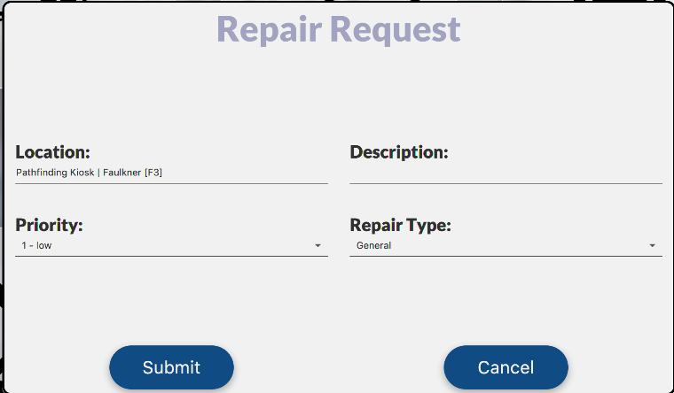Location: Requested Location  
Description  
Priority: [1 – 5]  
Repair Type: One of [General, Electrical, Plumbing]

## Transportation

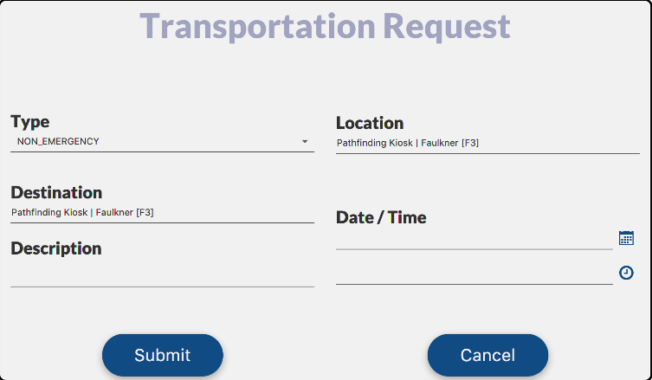Type: One of [Wheelchair, Stretcher, Walker, Shuttle Bus, Ambulance, Non-Emergency]  
Location: Location of pickup  
Destination  
Description  
Date and Time

## Mortuary (OLD)

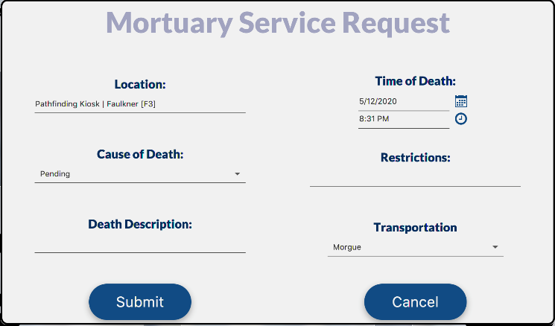Location: Location of pickup  
Cause of Death: [Natural, Accidental, Suicidal, Complications, Pending, Other]  
Death Description  
Time of Death (Time and Date)  
Restrictions: Description Transportation: One of [Morgue, Funeral Services, Off Campus]

*Note, this request has been deprecated and replaced by the Mortuary API in section 8.11.*

## Mortuary (API)

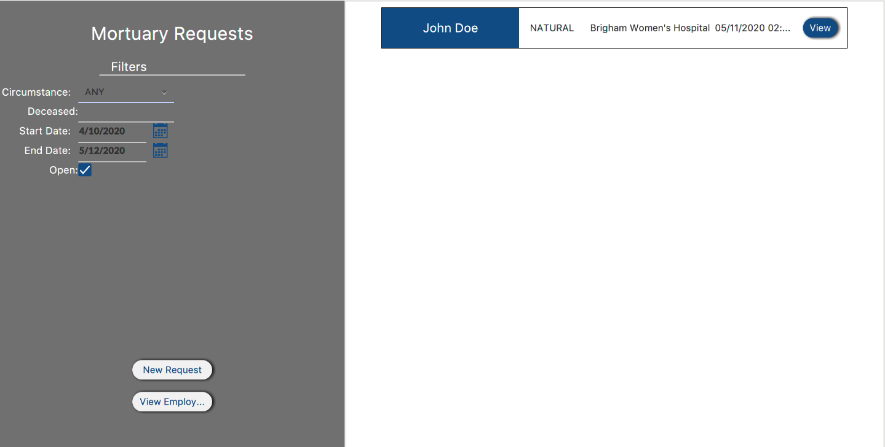

Figure 60 Mortuary API

The Mortuary request window is shown in Figure 57. On the left in the Grey Box, there are a set of filters that effect the order of the requests on the right in the White Box.

Accessible from the View button on each request; This window allows you to take actions on each request. You may edit the request, save changes or cancel them. Pressing Print Certificate, askes the staff member for a signature and then prints a death certificate based on the deceased’s information.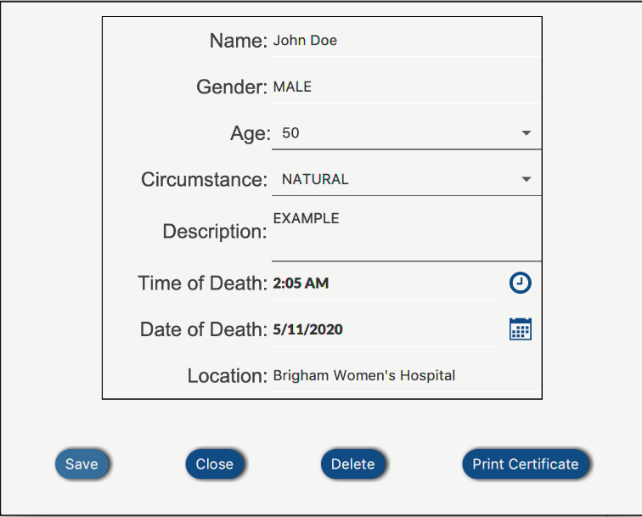

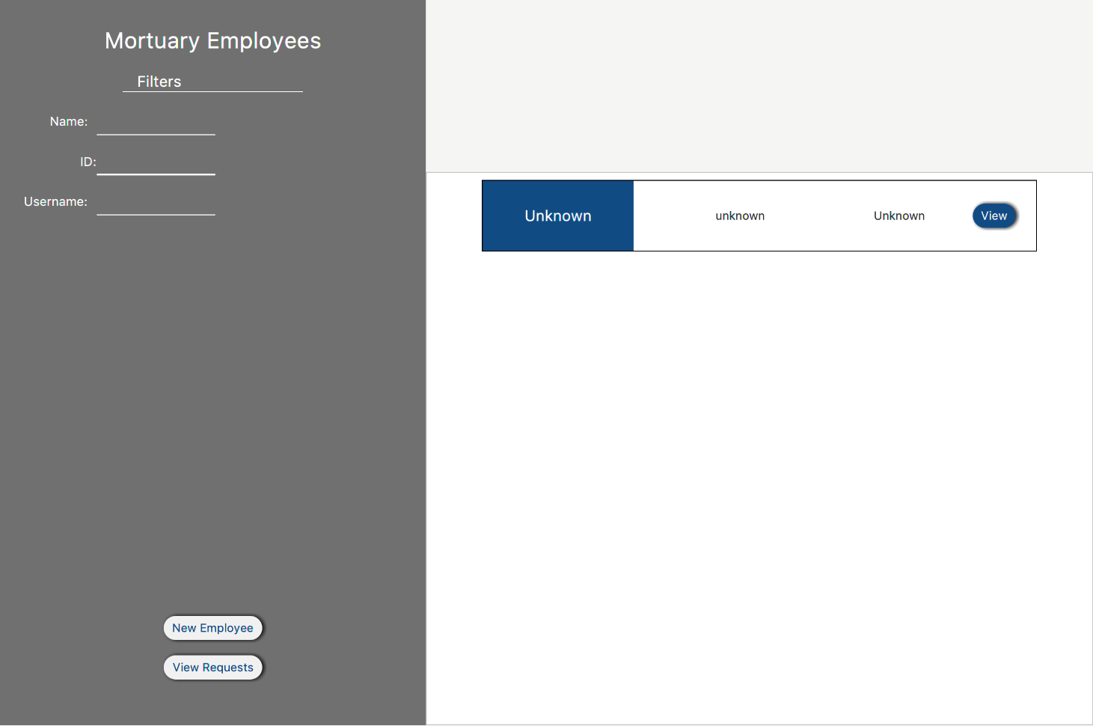

Table 8.1 Mortuary Employees

Accessible from Figure 57 the view Employees button; the above image allows staff to filter through employees with the fields in the Grey BOX. The entered employees sit filtered in the White Box and can be edited with the view button. The new Employee button allows staff to add an employee to the Mortuary employee List.

Accessible from Figure 57 the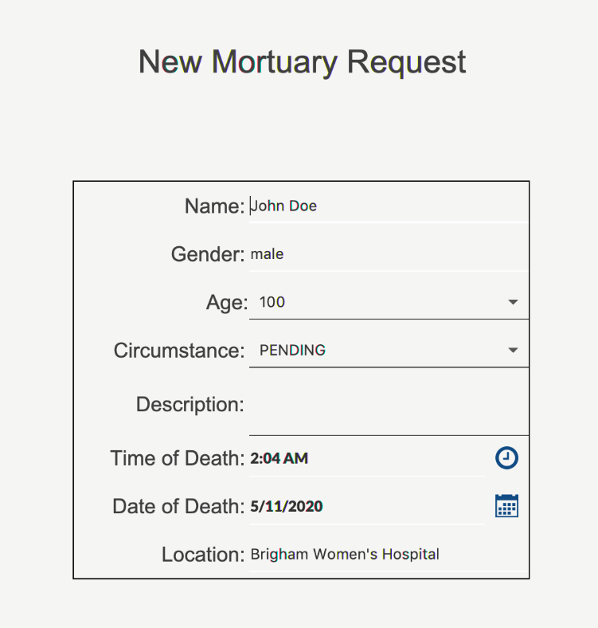 New Request button; allows staff top create a new request.  
Name: Deceased’s name  
Gender: Deceased’s gender  
Age: Deceased’s age  
Circumstance: One of [Natural, Disease, Accident, Complications, Suicide, Crime, Other, Pending]  
Description  
Time of Death  
Date of Death  
Hospital

## Viewing Non-API Requests

From the control panel in Figure 13, pressing requests will bring you to Figure 58. Here, you can view all internal service requests. They can be filtered by several fields including creator, assignee, type, are more.

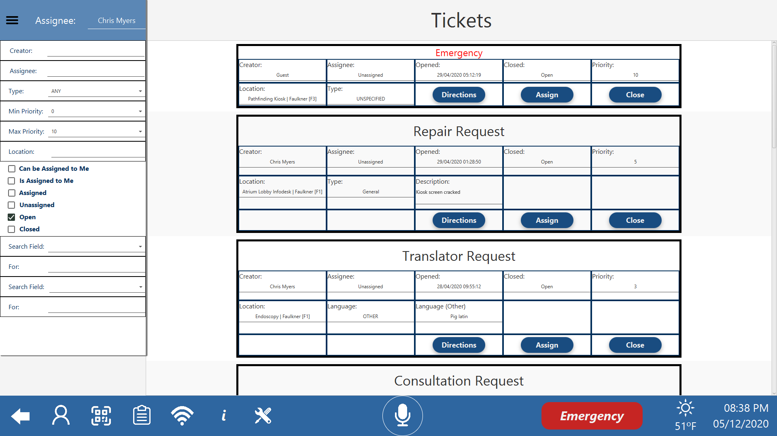

Figure 61 View Tickets Screen

# Administration Tools

The Administration tools are advanced tools accessible only to users with administrator privileges, such as network administrators, see 4.2 for signing in. These tools allow the admin to change the functionality of the application, through the settings menu, edit the locations on the maps, create and edit users, and import/export data from the database.

## Settings menu

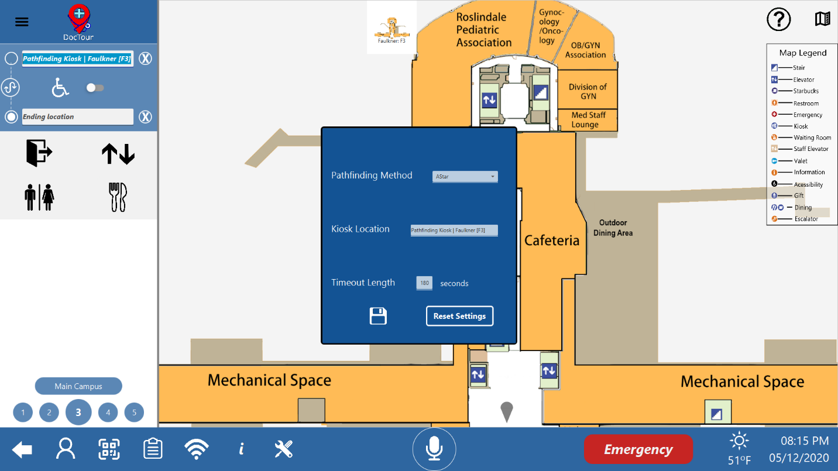

Figure 62 Settings Screen

The settings menu allows admins to adjust used in the application.

Pathfinding Method allows the admin to switch between one of four pathfinding algorithms: A-Star Depth First, Breadth First and Dijkstra. (Default: A-Star)

Kiosk Location allows the admin to change the location of this kiosk.

Timeout Length allows the admin to change the number of seconds before the user is logged out.

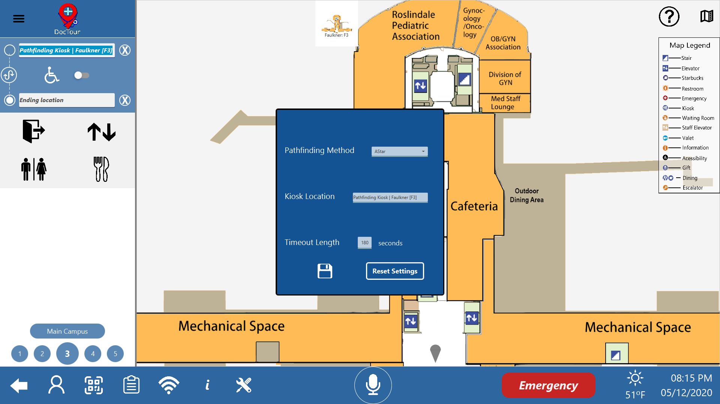

The save button saves the changes made in the previous fields.



The Reset Settings button changes the settings back to their default values.

## Admin Panel

Figure 63 Accessing the Admin Panel

The admin panel can be accessed by first logging in as an admin, and then selecting the new ‘Admin Panel Access’ Button on the System Bar. As seen in ‘Figure 60 Accessing the Admin Panel’, pressing the button. From the Admin Panel the Map Editor, and the User Management Screens can be accessed.

### Import/Export DB

From the Admin Panel there is a feature to reupload the current database or download the database. The ‘Export DB’ button will bring up a Directory Chooser, where the program will download the database to the selected directory. The ‘Import DB’ Button will take the selected folder, and if possible, replace the current database with the new selected Database. Use this function sparingly.

## Map Editor

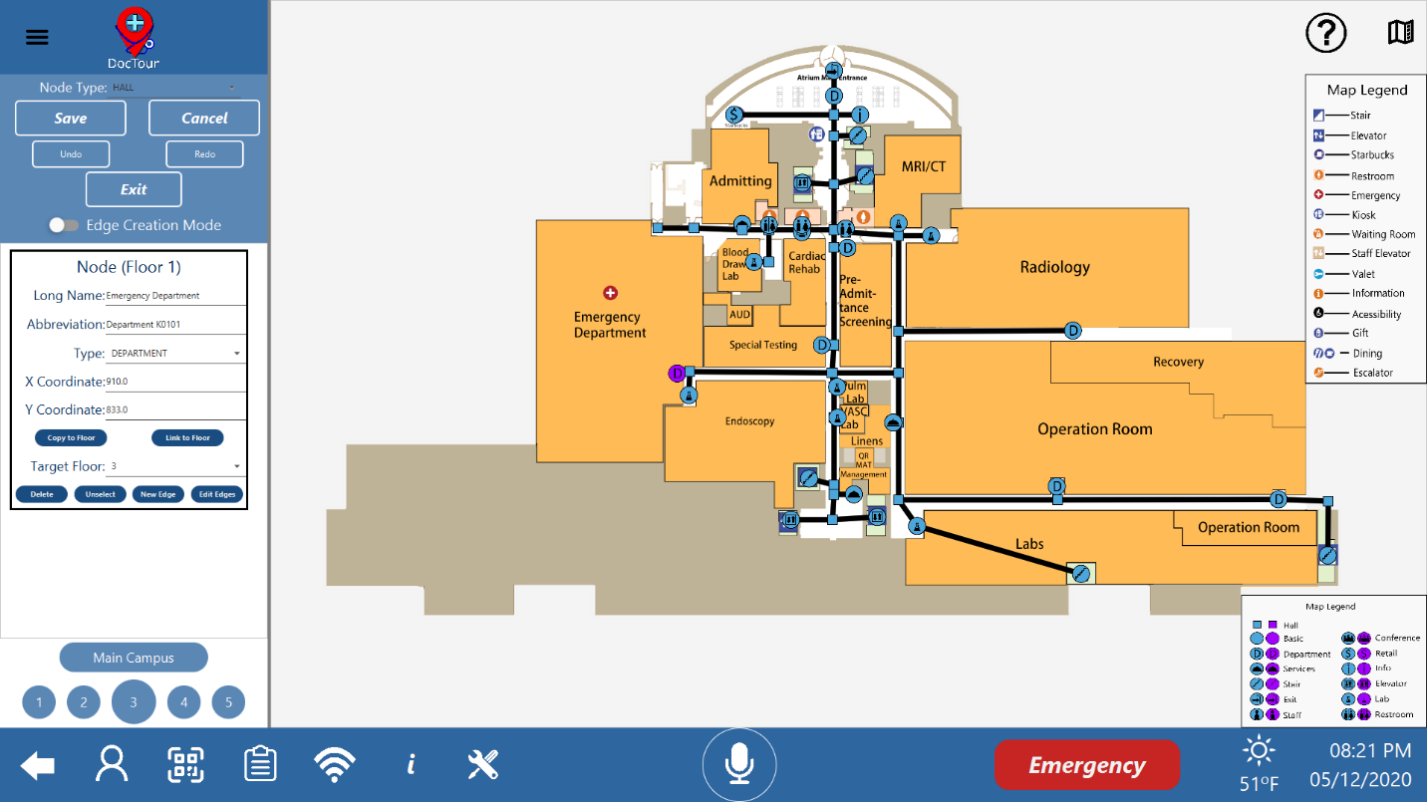

Figure 64 Editing Screen

Nodes can be dragged around the map by right clicking them and dragging the mouse around on the map. Alternatively, by clicking on a node a single time it will get selected and turn purple.

To place new nodes double click anywhere on the map.

### Editor Sidebar



Figure 65 Editor Sidebar

The Node Type field, at the top of the sidebar, allows the user to change between the different node types for newly placed nodes.

The Save button saves changes made to the map so that they are kept upon exiting.

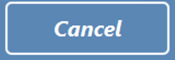

The Cancel button discards changes made to the map.



The Undo button undoes the most recent action.



The Redo button redoes the most recently undone action.

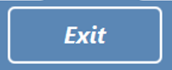

The Exit button exits the editor returning the user to the main map.

The floor and building buttons function the same as those found on the main pathfinding screen.

#### Node Editing



Figure 66 Edit a Node

There are five fields for editing nodes, as shown in Figure 63. for how to select a node. Long Name and Abbreviation can be filled with text, Long Name denoting the full name of the node and Abbreviation its abbreviation. The Type field has a drop down used to change the node between the different types. The X and Y coordinates can be filled with numbers to set the coordinates of the Node on the map.

Bellow these fields are two buttons and a drop-down menu. The copy to floor button makes a duplicate of the node on the floor shown in the drop-down. The link to floor button links the node to another node on the floor selected in the dropdown

Bellow the Target Floor drop-down, there are four buttons Delete, Unselect, New Edge, and Edit Edges. The Delete button deletes the node and the Unselect button deselects the node. The New Edge button creates an edge that starts at the selected node and opens and edge editor, see 9.3.1.2 for how to use the edge editor. And lastly the Edit Edges button selects all the edges connecting to the node, opening edge editors for each of them.

#### Edge Editing

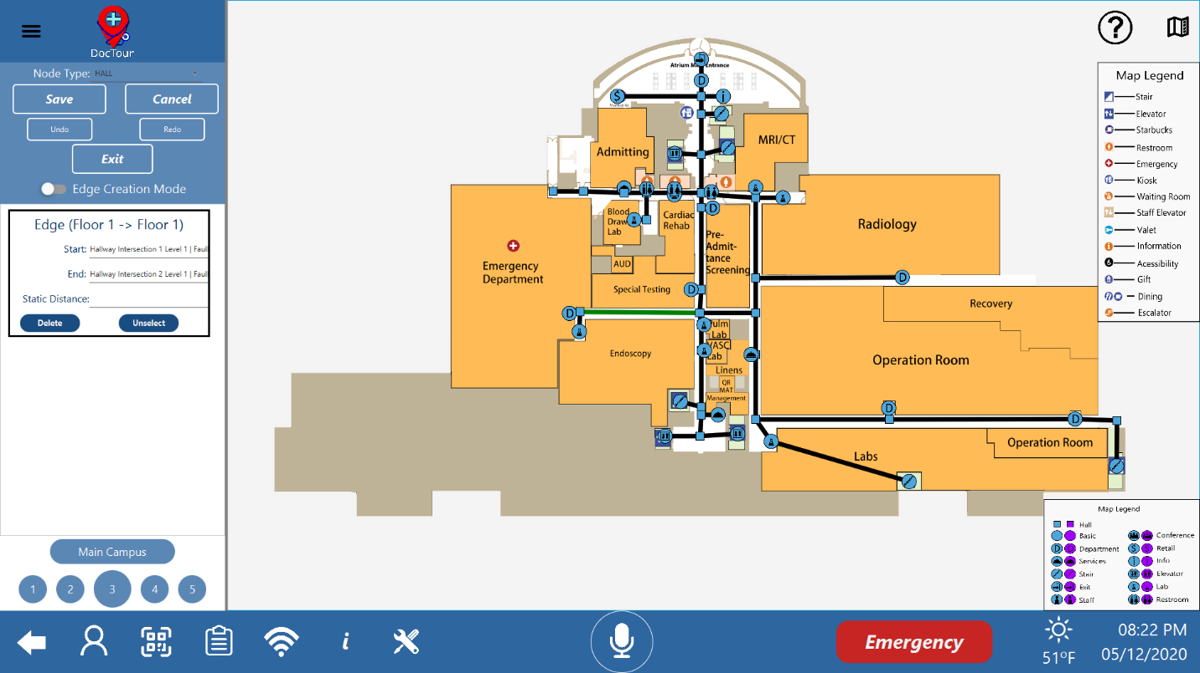

Figure 67 Edit an Edge

In the edge editor there are three fields, the start and end fields select the nodes the edge connects between. The third field allows the user to set a static distance for the edge (used primarily for connecting different buildings to prevent pathfinding issues, the recommended setting for connecting buildings is the maximum 999).

## User Management

Clicking the “Users” button will take the Administrator to the Users Menu, where they will have several options to choose from to manipulate the Users Database in the program.

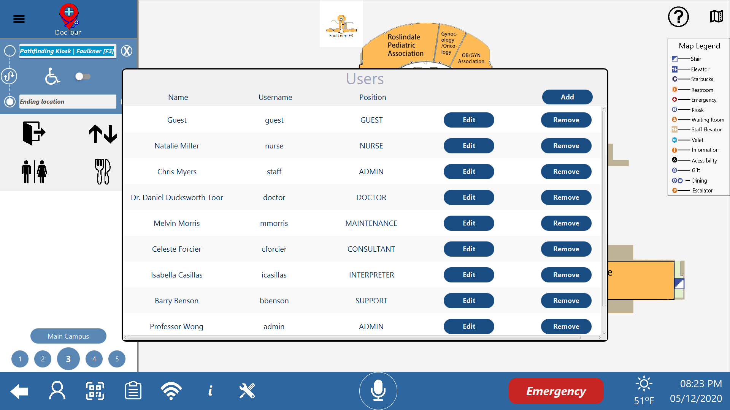

Figure 68 The Users Menu

Each row in this table represents a user in the system, and displays their Full Name, their username, and the position they hold. Beside each set of information are two buttons:



The Edit button allows for an Administrator to update or change information for a given user, specifically their Name, their login name, and their occupation within the hospital.

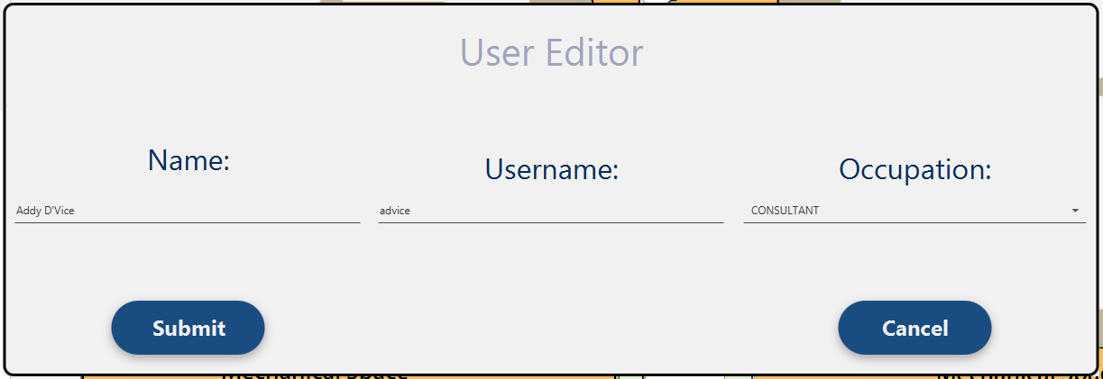

Figure 69 The Edit User Window



The Remove button allows for an Administrator to delete a user from the system, disabling them from being able to log in. Doing so is permanent. In the event a user is deleted accidentally, they will have to be manually added back into the system, using the final feature of the users Window.



The Add button allows an Administrator to add a new user into the database. They will be prompted to enter the new users Full name, their login name, their Occupation, a default password for them, and a default pin in the event they sign in via QR. Clicking submit will add a user to the system, assuming all the relevant fields were entered, and clicking cancel will take them back to the Users Screen.

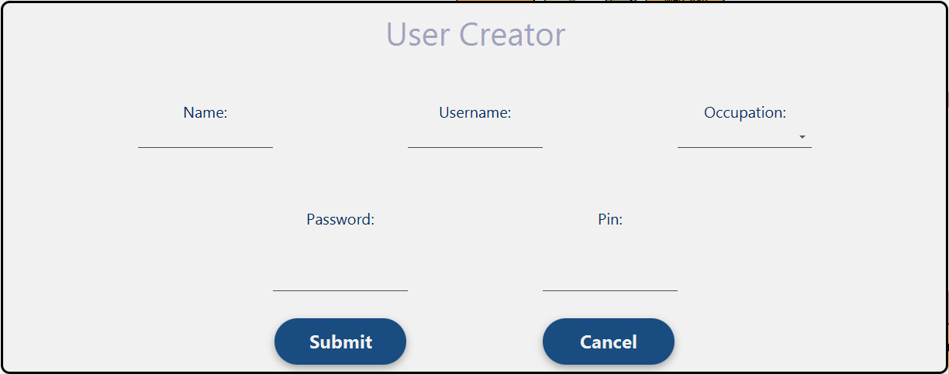

Figure 70 The User Creation Screen

# Acknowledgments

All the members of Team Khaki Kappas would like to thank the follow people:

* Team A for their Flower Request API
* Team B for their Secure Incident Reporting API
* Team C for their Interpreter Request API
* Team D for their Internal Transport Request API
* Team E for their On-Call Beds API
* Team F for their Maintenance Request API
* Team L for their Gift Delivery Service Request API
* Team M for their Audio-Visual Request API
* Team N for their Sanitation Request API
* Team O for their Security Service Request API
* Team P for their Food Request API
* Wilson Wong, the Software Engineering course instructor, for his guidance throughout this class
* Chris Myers, our team coach, for helping us out of tough situations and his helpful advice
* The staff at Brigham and Women’s Hospital for allowing us to use their hospital in our application